Locator outline
- Deployment channels
  - The Steam Pigeon locator has 4 independent deployment channels, intended to work with e-matches such as MJG Firewire with a rated all fire current requirement of 1A or less. Always test any e-match brands not specifically mentioned here before flying.
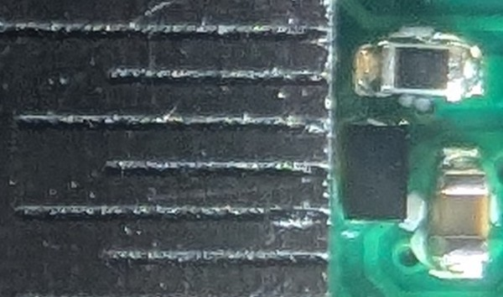
- Battery care
  - Lithium-ion batteries should be stored in an environment where the temperature is between 10°C and 25°C (50°F to 77°F) and can operate safely up to 60°C (140°F). Operating above this limit increases the risk of fire or explosion from thermal runaway or pressure buildup. Battery charging of lithium-ion batteries is not recommended above 45°C (113°F).
- Altimeter
  - The MS5611 is a capable barometric pressure sensor well suited to high power amateur rocketry with a maximum usable altitude of ~98,000 feet. The Steam Pigeon locator uses temperature measurements provided by the MS5611 to compensate for changes in temperature. To achieve the best accuracy, keep the sensor out of direct sunlight, which can cause sudden jumps in temperature of several degrees, impacting altitude readings. Normally this is not an issue, unless the locator is housed in a transparent section of the rocket. 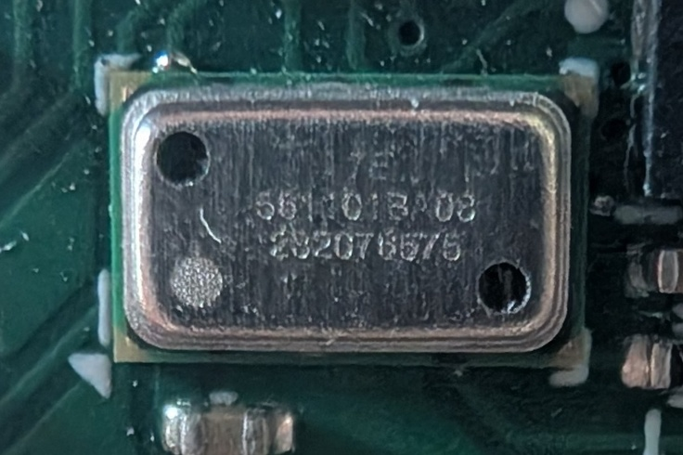
- Bluetooth
  - If you change the name of your receiver, the new name won’t update on the app (it’s also the same in your phone settings because it’s a function of Bluetooth, not unique to Steam Pigeon) until you “Forget” the connection in your phone settings.
- GPS
  - The SAM-M10Q supports concurrent reception of four GNSS (GPS, GLONASS, Galileo, and BeiDou). The high number of visible satellites enables the receiver to select the best signals. This maximizes the position availability under challenging conditions. u-blox Super-S (Super-Signal) technology offers great RF sensitivity and can improve the dynamic position accuracy in non-line-of-sight scenarios. If you experience issues with location accuracy, try the following:
    - Adjust the position of the locator within your rocket, avoiding potential RF shields such as metal and carbon fiber. The GPS unit will perform better if the antenna has as clear a view as possible of the sky.
    - Start the locator in the open, confirm GPS lock (green LED near the GPS antenna begins blinking), then install the locator in your rocket.
- Deployment Charge Setup
  - Connect ematches to the desired deployment channel screw terminals
  - While pointing ematches away from anything you value including yourself, turn on the locator. The locator is designed to start up in a no-fire state, but caution should always be taken nonetheless.
  - Turn off the locator.
  - Add black powder.
  - Turn on the locator at the launch pad.

